SNARC – A Semantic Social News Aggregator
Ahmad Assaf†, Aline Senart† and Raphaël Troncy††
†SAP Research, SAP Labs France SAS
805 avenue du Dr. Maurice Donat, BP 1216, 06254 Mougins Cedex, France
First.last@sap.com
†† EURECOM
2229 route des crètes, 06560 Sophia Antipolis, France
raphael.troncy@eurecom.fr

Abstract. The Internet has created a paradigm shift in how we consume and disseminate Knowledge. Information nowadays is spread over heterogeneous silos of archived and live data. Social media sources are fundamentally based on the fact that people willingly share information and data by posting news, views, presentations, pictures and videos. Social media is a source of live and up-to-date knowledge; a property that was lacking in traditional sources. SNARC is a service implemented as a browser extension that aims at presenting this live knowledge to the user directly on the page he is browsing; giving him the ability to consume related and up-to-date information directly.
Keywords: Social News, Social networks, Aggregator, Data mining, Mashup, Automatic Tagging, Named entity recognition
1 Introduction
With the rapid advances of the Internet, social media became more and more intertwined with our daily lives. The ubiquitous nature of Web-enabled devices especially mobile phones, enabled users to participate and interact in various formats like photo and video sharing platforms, forums, newsgroups, blogs, micro-blogs, bookmarking services, and location-based services. Social networks are not just gathering Internet users into groups of common interests, they are also helping people follow breaking news, contribute to online debates or learn from others. They are transforming online user behavior in terms of users’ initial entry point, search, browsing and purchasing behavior.
A common scenario that happens while browsing the web is that we read an interesting article, come across a nice video or participate in a discussion in a forum; afterwards we might be interested in the information read and would love to check related material, we can go to Twitter, Google+ or YouTube to dig for more information; we can try several times with several keywords to obtain the desired results. In the end, we might end up with several browser tabs opened and we are often distracted with information overload from all these resources. SNARC leverages live rich data that social networks provide to build an interactive rich experience on the Internet. It is implemented as a browser extension so that it can be launched on any webpage. It retrieves related news from popular platforms like Twitter, Google+, YouTube, Vimeo, Slideshare, Stackoverflow and the Web.
2 Underlying Mechanism
The flexibility of implementing SNARC as a chrome extension allows it to be launched on any type of web pages. However, this requires that its functionalities are implemented as web services. The JSON results are retrieved by doing an AJAX call which are parsed afterwards on the frontend directly. The back-end of SNARC consists of three major components – first, a document handler, second a query layer and last, a data parser which processes the search results to generate the desired output (Fig. 1). We describe below the components in detail.

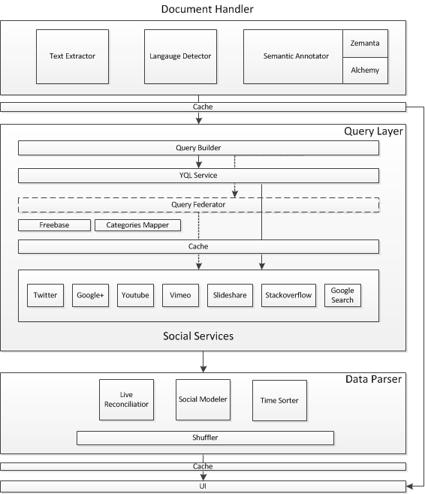
Figure 1 SNARC Architecture

2.1 Document Handler
This is the only call made to the SNARC service with the URL of the active browser tab as the only parameter. There are three main steps to prepare the document.
- Fetch the webpage that corresponds to the parameterized URL and extract the textual content using a set of heuristics that basically try to identify the main content of the page by stripping unwanted HTML tags and rank the different sections based on their semantics, class names and order. In the beginning we have used Alchemy API to perform text extraction; but we have chosen to implement a simple method that extracts the basic content which saved us an extra API call.
- Detect the webpage language using the Language Detection service of Alchemy API. This step is important to fetch results that match the desired language from compatible services like Twitter.
- The semantic annotation is the most important step in this phase. We need to identify the most important keywords (tags) that describe best the extracted text. These “tags” are used as the base query from the different sources. Keyword extraction is done using the Zemanta Suggest and Alchemy’s Keyword Extraction APIs. Fundamentally, they employ sophisticated statistical algorithms and natural language processing technologies to analyze the text and extract keywords. However, the results from these two services can differ significantly. We mainly rank the results retrieved from Zemanta higher as we have found that they are more accurate in describing the content semantically. In addition to the “tagging” process, we also need to map the text to high level taxonomies; this is important when querying services like YouTube where we can execute our query on specific categories. This process is done using Alchemy’s Text Categorization API.

At the end of this process, we will have the needed input elements (keywords “tags” and high level categories) to be passed to the query generator.

2.1 Query Layer
This is the place where the calls to the social services are made. The set of services are defined in an array and are passed as a parameter. Adding a new search service is easy; we just need to extend the Social_Search class and add the service name to the parameters list.

The query builder is responsible for building tailored queries for each service. To enhance the performance we tried to reduce the number of external calls to the minimum. An approach for doing so is to use the Yahoo Query Language (YQL) . It is an expressive SQL-like language that lets you query, filter, and join data across Web services. Using YQL helped us minimize the number of calls and batch them into a single one. However; we have found that we cannot fully rely on YQL; due to their API calls limit and the restriction on the query’s execution time that is set to 30 seconds. To overcome this, we have implemented a fallback mechanism that federates the queries to all the social services and groups the result to be passed afterwards to the parser.

To minimize the number of calls as well, we have decided to take the top two ranked keywords (tags). Keywords are not gathered in a query by any logical operator (AND/OR); a one-to-one mapping is done with each keyword and query. We have decided to do so, as we have found that gathering keywords even if semantically related might bring up noise in the results.

The main setback in the query layer was the variable limited number of calls we can make to external APIs. To overcome this, we have implemented a simple cache mechanism that saves the results on disk up to an hour. There are several cache levels; the first is a URL level one where the results of the parsed queries are cached. For example, if a user visited a certain article on the CNN webpage; the results might take up to 15 seconds to appear, whereas a second user visiting the same article minutes afterwards will have the results shown in a matter of few seconds. The second level is keyword and service specific; this can be very helpful as users generally browse articles of related topics or interests (semantic concepts), so for each user we can end up with the same high level concepts being requested frequently. An important thing to note is that the caching is done on the server side and is disk based; a future work plan is to gather all the acquired parsed knowledge in a triple store.

The social services queried can be grouped as the following:

- Multimedia Services: They include Slideshare, Vimeo and YouTube. Slideshare and YouTube allow the results to be fetched in a specific language that was detected earlier in the previous step. In addition to that, YouTube search services are called twice; the first call is done to the YouTube V2 API where we specify in addition to the keywords a high level category to be targeted. To do so, we have implemented a Categories Mapper function that maps the high levels categories of Alchemy’s API with those provided by YouTube. The second call is done to YouTube V3 API. The new feature provided by Google in this version is the ability to search using a semantic concept that corresponds to a Freebase concept ID; this is very important as it proved to retrieve better results that the normal search. Freebase concept calls are cached for longer periods as they are less prone to changes.
- Microposts Services: They include Twitter, Google+ and Stackoverflow. Language filtering is done where applicable.
- General Search: This includes similar results found via Google search or those retrieved from the Zemanta API call. They are general articles or blog posts related to the current active page.

At the end of this process, we will end up with a relatively big JSON file containing all the results retrieved from all the services; they are grouped by the corresponding service name that identifies the parser which will handle them in the next step.

2.1 Data Parser
This is where we unify the results and wrap them in a single social model. Adding a new parser is easy, we just need to implement the social_parser interface which produces a social_service object.

Social (or folksonomic) tagging became a trending method to describe, search and discover content on the web. Folksonomies empower users by giving them total freedom in choosing their categories (tags) that they think describe best the content. This contrasts with taxonomies that over-impose hierarchical categorization of content [1]. However, in services like Twitter and Google+; tagging has been abused in a way that increased noise in the stream of results. To overcome this problem; we need to align the incoming stream of posts with the set of semantic concepts or keywords that describe the document. There are several approaches and tools like [1][3][4][5] that aim at solving this problem; investigating them deeply and integrating what is appropriate is part of the future work planned. We rely on two levels of reconciliation: one uses the keywords and the second one exploits the high level taxonomy extracted from Zemanta and Alchemy; this process is influenced by the reconciliation module implemented in [2].

The social modeler is the process where the social_service object is created in order to capture all the information needed from the several services. The object container the following attributes:
- Service related information: Service Name, Service Type.
- General post information: Author Name, Author Profile Link, Author Image, Time, Geo-location, Program
- Post information: Title, Thumbnail, Embed code, Content, Link

So far, we have filtered the results returned and wrapped them in a common social mode. Since the number of results can be quite large sometimes (though we have set a limit for the results returned in the query layer) we need to show the most recent results first. To do so; we need to unify the time representation and sort the results based on it; afterwards we pick the top N results and shuffle them in order to view them nicely in the front-end. Figure 2 shows a sample of the output generated from the parser.
{
"time": "1 day ago",
"service": "vimeo",
"type": "video",
"title": "DepthJS",
"author": "Fluid Interfaces",
"thumbnail": {
"height": "150",
"width": "200",
"_content": "http:\/\/b.vimeocdn.com\/ts\/106\/362\/106362522_200.jpg"
},
"embed": "<iframe src=\"http:\/\/player.vimeo.com\/video\/17180651\" width=\"1920\" height=\"1080\" frameborder=\"0\" webkitAllowFullScreen mozallowfullscreen allowFullScreen><\/iframe>",
"link": "http:\/\/vimeo.com\/17180651"
},
{
"time": "44 minutes ago",
"service": "twitter",
"type": "micropost",
"title": "How to Properly Ask for <a href='http:\/\/twitter.com\/search?q=%23WordPress' target='_blank'>#WordPress<\/a> Support and Get It - <a href=\"http:\/\/t.co\/kqH3BcuUK0\" target=\"_blank\">http:\/\/t.co\/kqH3BcuUK0<\/a>",
"author": "wpbeginner",
"thumbnail": "http:\/\/a0.twimg.com\/profile_images\/731041180\/wpbeginnertwitterimg_normal.jpg",
"link": "315927513811521537",
"program": "<a href=\"http:\/\/bufferapp.com\" rel=\"nofollow\">Buffer<\/a>"
},
Figure 2 Data Parser JSON Sample

3 Front-End
The JSON file generated from the parser is passed then as the result of the AJAX call to the front-end. They are visualized using jQuery templates as a sliding panel on one of the screen edges. The items are scrolled automatically as an infinite carousel, and the animation is paused when the user is active on the reserved area. To minimize the load time, only the first rich multimedia object is embedded, while the others are only shown on request. Figure 3 shows two screenshots of SNARC’s.
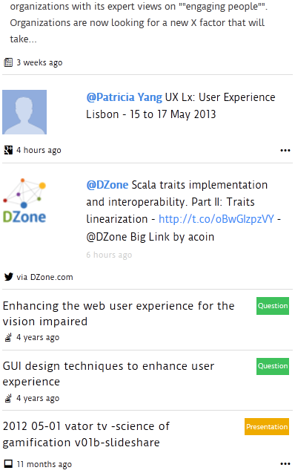
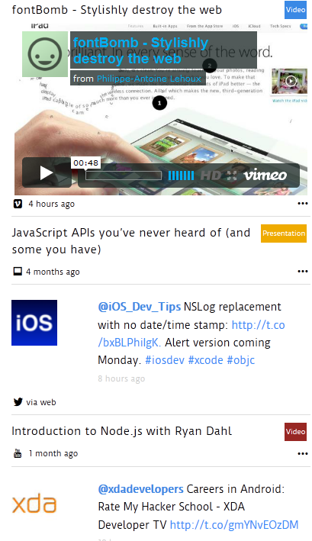
Figure 3 SNARC UI
4 Conclusion and Future Work
Aggregating relevant social news is not an easy task. SNARC is a modest attempt to perform the task in a nice and intuitive way; that allows the user to discover what is happening instantly and without the need to navigate away from the current page. One of the important things to consider for the future is the integration of better reconciliation features and tools to ensure the display of relevant social posts. Moreover; the introduction of real-time feature than can also push new related posts. Finally, we can also introduce improved recommended content; like people to follow on Twitter or Google+ [6] or video channels to subscribe to.
5 References
- Zanardi, V and Capra, L (2008) Social Ranking: Uncovering Relevant Content Using Tag-based Recommender Systems. In: RECSYS'08: PROCEEDINGS OF THE 2008 ACM CONFERENCE ON RECOMMENDER SYSTEMS. (pp. 51 - 58). ASSOC COMPUTING MACHINERY
- H Khrouf, G Atemezing, G Rizzo, R Troncy, T Steiner. Aggregating Social Media for Enhancing Conference Experiences. Proceedings of the 1st Int. Workshop on Real-Time Analysis and Mining of Social Streams 01/2012
- Preotiuc-Pietro, Daniel, Samangooei, Sina, Cohn, Trevor, Gibbins, Nicholas and Niranjan, Mahesan (2012) Trendminer: an architecture for real time analysis of social media text. In, 6th International AAAI Conference on Weblogs and Social Media (ICWSM-12), Dublin, IE, 05 - 07 Jun 2012. 5pp
- Iván Cantador, Alejandro Bellogín, Ignacio Fernández-Tobías, Sergio López-Hernández edited by Christian Huemer, Thomas Setzer, Will Aalst, et al. Semantic Contextualisation of Social Tag-Based Profiles and Item Recommendations E-Commerce and Web Technologies Vol. 85 (2011), pp. 101-113
- Ernesto Diaz-Aviles, Lucas Drumond, Lars Schmidt-Thieme, and Wolfgang Nejdl. 2012. Real-time top-n recommendation in social streams. In Proceedings of the sixth ACM conference on Recommender systems (RecSys '12). ACM, New York, NY, USA, 59-66.
- Marco Pennacchiotti and Siva Gurumurthy. 2011. Investigating topic models for social media user recommendation. In Proceedings of the 20th international conference companion on World wide web (WWW '11). ACM, New York, NY, USA

http://www.twitter.com
http://plus.google.com
http://www.youtube.com
http://www.vimeo.com
http://www.slideshare.com
http://www.stackoverflow.com
http://www.alchemyapi.com/
http://developer.zemanta.com/docs/suggest/
http://developer.yahoo.com/yql/
https://developers.google.com/youtube/2.0/developers_guide_protocol_category_keyword_browsing
https://developers.google.com/youtube/v3/

